AUTH-028
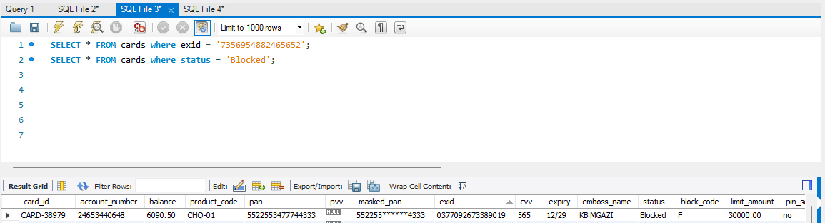
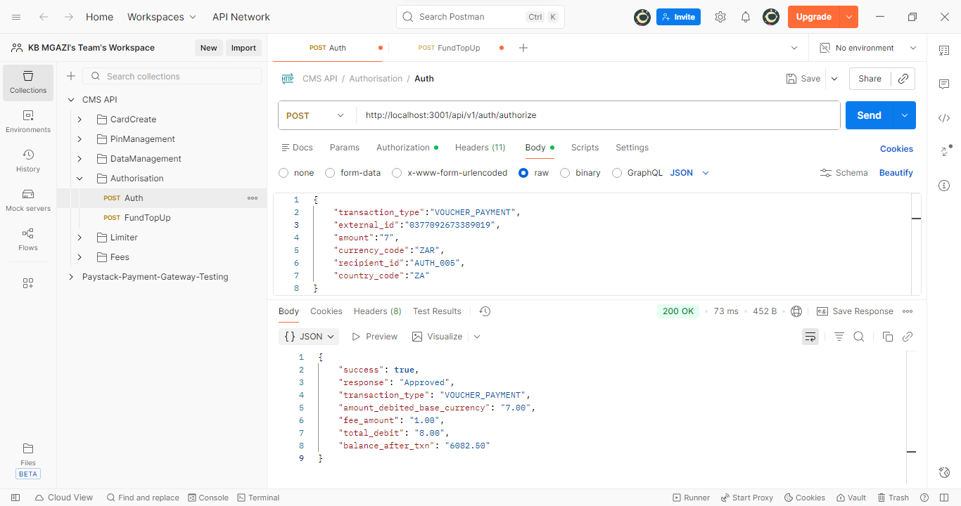
Request:
{
"transaction_type":"VOUCHER_PAYMENT",
"external_id":"0377092673389019",
"amount":"7",
"currency_code":"ZAR",
"recipient_id":"AUTH_005",
"country_code":"ZA"
}
Response:
{
"success": true,
"response": "Approved",
"transaction_type": "VOUCHER_PAYMENT",
"amount_debited_base_currency": "7.00",
"fee_amount": "1.00",
"total_debit": "8.00",
"balance_after_txn": "6082.50"
}

